I have find a solution to control emotional trading and make it algo.
- Create a trade bot application which actually
  - Connect the application with Fyers broker account through the API key they provided
  - using this API need to connect with brokers backend API do the following application functionalities
- The application should mainly contains
  - 2FA providing page
    - A dedicated page which provide the timely 2FA TPOP code based on the provided seed from my Fyers application authentication
    - When click on the get token button will provide the token value
- The other functionalities include,
Building a standalone algorithmic and manual trading application requires a decoupled architecture. By leveraging the Fyers API, your application becomes the primary interface, eliminating the need to log into the Kite web platform during market hours.
Here is how the data flows between your application and Fyers'servers:
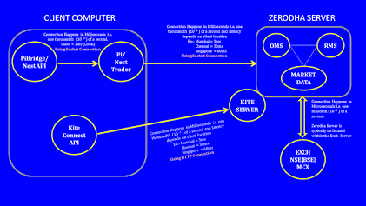
To achieve complete independence from the Kite UI while supporting both automated algorithms and manual interventions, your application needs the following architecture.

1. Core Backend Modules (The Engine)
These headless components run continuously in the background, processing data and executing logic.
- Authentication Manager: Fyers mandates a daily login to generate a new access_token. This module handles the OAuth redirect flow, captures the request token, and maintains the active session.
- Market Data Ingestion (Ticker): Manages a persistent WebSocket connection to stream live tick data (LTP, volume, bid/ask) with low latency. It also handles REST API calls to fetch historical candle data for indicator calculations.
- Strategy Engine: The algorithmic brain. It subscribes to the ticker stream, calculates technical indicators in real-time, and generates buy/sell signals based on your predefined rules.
- Risk Management System (RMS): The safety net. It intercepts every signal before execution to check against constraints like maximum daily loss, position sizing limits, and total margin utilization.
- Order Management System (OMS): Executes the validated signals via the API. It tracks the lifecycle of an order (pending, executed, rejected) and handles retries or modifications.

2. Application Pages (The Frontend UI)
Since you want to manage both the bot and manual trades from this app, your user interface should be clean, flat, and focused on execution speed.
- API Configuration & Login: A simple setup page to input your api_key and api_secret, alongside a button to initiate the daily login flow and save the session token.
- Master Dashboard: The control center. It should display your consolidated daily P&L, available margin, active positions, and a master "Kill Switch" to halt all automated trading instantly.
- Strategy Control Panel: A page to view all available algorithms. You should be able to toggle them On/Off individually and adjust live parameters (e.g., tweaking the take-profit target) without restarting the application.
- Manual Trading Terminal: A dedicated screen for discretionary or event-driven trading.
  - Features: Search bar for adding instruments, real-time LTP display, and quick-action execution buttons (Market Buy/Sell).
  - Emergency Controls: Prominent buttons to "Square Off All Positions" and "Cancel All Pending Orders."
- Order Book & Trade Log: A synchronized table displaying your executed trades, open orders, and rejections. A separate sub-tab should display raw system logs (e.g., WebSocket disconnects, API rate limit warnings) for debugging.
Explore how these modules interact with each other in real-time to process market data and execute trades: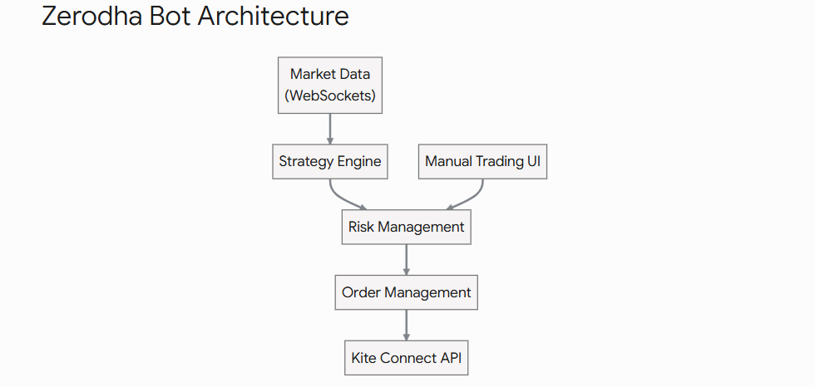

Designing a trading interface that mimics Fyers’s clean, flat aesthetic while preparing for a future mobile app requires a strictly decoupled architecture. By completely separating your frontend UI from your core execution logic, you can seamlessly reuse the exact same backend API for both your web platform and your future mobile application.
Here is a breakdown of how to structure the pages, features, and underlying architecture for this system.
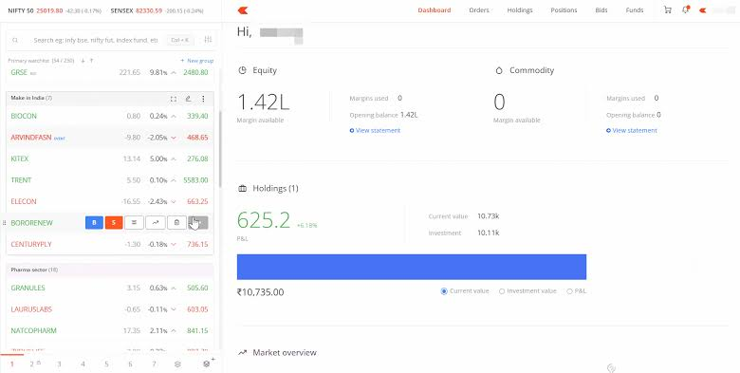
Classic Split-Panel Trading Interface. Source: Fyers

The Decoupled Architecture

Core UI Modules & Pages
To recreate the Fyers experience, utilize a flat design theme. A deep, professional base color (like #0033a0) works exceptionally well for the header and active states, providing high contrast against the red and green typography used for live market data.
The application should be divided into a Left Sidebar (Watchlist) and a Main Content Area (Tabbed Pages).

1. The Watchlist Panel (Persistent Left Sidebar)
This component stays on the screen at all times so you can always see live prices, even while checking your order book.
- Multiple Watchlists: Allow the creation of 5 to 7 list groups (e.g., "Nifty 50," "Holdings," "Options").
- Smart Search: Your Python backend must download the CSV dump of all tradable instruments from Fyers every morning. When a user types in the search bar, the frontend queries this local database for instantaneous results.
  - Stock: Searching "RELIANCE" pulls the equity token.
  - Options: Searching the underlying, expiry, and strike (e.g., "Nifty 17000 CE" or "BankNifty Sep Fut") pulls the specific derivative contract.
- Hover Actions: When hovering over a watchlist item, reveal quick-action buttons: [ B ] (Buy), [ S ] (Sell), Market Depth, and Chart.

2. Positions Page (Main Panel)
This is where you monitor intraday active trades (MIS) and overnight F&O positions (NRML).
- Data Points: Instrument name, Net Quantity, Average Price, Last Traded Price (LTP), and real-time Mark-to-Market (MTM) Profit/Loss.
- Actions: A prominent "Square Off" button next to each position.
- Logic: The MTM must update on every tick received from your WebSocket. If your bot places a trade, it should instantly appear here without requiring a page refresh.

3. Holdings Page (Main Panel)
This represents your long-term portfolio (CNC orders) resting in your demat account.
- Data Points: Invested amount, Current Value, Day's P&L, and Total P&L.
- Authorization: If a user tries to sell a holding, the UI must prompt for CDSL TPIN authorization (unless you have submitted a Power of Attorney to the broker).

4. Order Book Page (Main Panel)
A ledger of all daily trading activity. It should be split into two sub-tabs:
- Open Orders: Pending limit or stop-loss orders. Must include a one-click "Cancel" and "Modify" button.
- Executed/Rejected: A historical log of completed trades and failed orders. Crucially, if an order is rejected, the UI must clearly display the rejection reason (e.g., "Insufficient Margin") returned by the Kite API.

5. The Order Execution Modal
When clicking "Buy" or "Sell" from the watchlist, a clean overlay modal should appear.
- Inputs: Quantity, Price (for limit orders), Trigger Price (for SL orders).
- Toggles: Intraday (MIS) vs. Longterm (CNC/NRML), and Market vs. Limit.
- Margin Calculator: A small text area at the bottom that dynamically calculates the required margin based on the entered quantity and live price before the user submits the order.

To make your React web application fully responsive for mobile browsers—while keeping the decoupled architecture intact for your future native app—you must shift from a side-by-side desktop layout to a stacked, mobile-first paradigm.
A trading UI requires high-density information. Simply shrinking a desktop dashboard makes the text unreadable and the buttons too hard to tap accurately during fast market movements.

Responsive Layout Strategy
To achieve a seamless transition between desktop and mobile using Next.js and Tailwind CSS (or standard CSS), your layout needs to break at specific widths (e.g., max-width: 768px).
Instead of duplicating your React components, use CSS media queries or a custom React hook (like useMediaQuery) to change where and how those components render.
Here is how the core modules adapt for mobile screens:

1. The Navigation Shift (Sidebar to Bottom Bar)
On a desktop, your Watchlist is a persistent left sidebar. On mobile, screen real estate is too valuable.
- Mobile view: The sidebar disappears entirely. Instead, implement a fixed Bottom Navigation Bar with icons for Watchlist, Orders, Portfolio (Holdings/Positions), and Profile.
- This mimics the native app experience and keeps navigation within easy reach of the user's thumb.

2. Watchlist Interactions (Hover vs. Tap)
Mobile devices do not have a "hover" state.
- Desktop view: Hovering over "RELIANCE" reveals the Buy (B) and Sell (S) buttons.
- Mobile view: Tapping a stock row should expand it downward (an accordion) to reveal the Buy/Sell buttons, Market Depth, and Chart icon. Alternatively, implement a swipe-left gesture on the row to reveal the action buttons.

3. Order Execution (Modal to Bottom Sheet)
The order entry form must be fast and error-free.
- Desktop view: Clicking "Buy" opens a central floating modal overlay.
- Mobile view: The same <OrderExecutionForm/> component should render inside a Bottom Sheet that slides up from the bottom of the screen. This ensures the Quantity and Price input fields are immediately above the mobile keyboard, and the prominent Buy/Sell buttons (styled against your #0033a0 base color) are easily accessible at the bottom edge.

4. Data Grids (Horizontal Scrolling)
Your Orders and Positions pages contain many columns (Instrument, Qty, Avg Price, LTP, MTM).
- Mobile view: Do not try to squash six columns into a mobile screen. Keep the primary data (Instrument name and MTM P&L) visible on the left and right edges of the row. Hide secondary data (like exact execution time) behind a tap, or allow the table to scroll horizontally independently of the rest of the page.
Explore how these layout shifts function as the screen size changes:
Key Insight for Future-Proofing: By building your web app's UI components with strict separation from the data-fetching layer, migrating to React Native later becomes much simpler. You can reuse your custom hooks (e.g., useWebSocket, useOrderSubmit) completely untouched; you will only need to rewrite the HTML <div> tags into React Native <View> components.
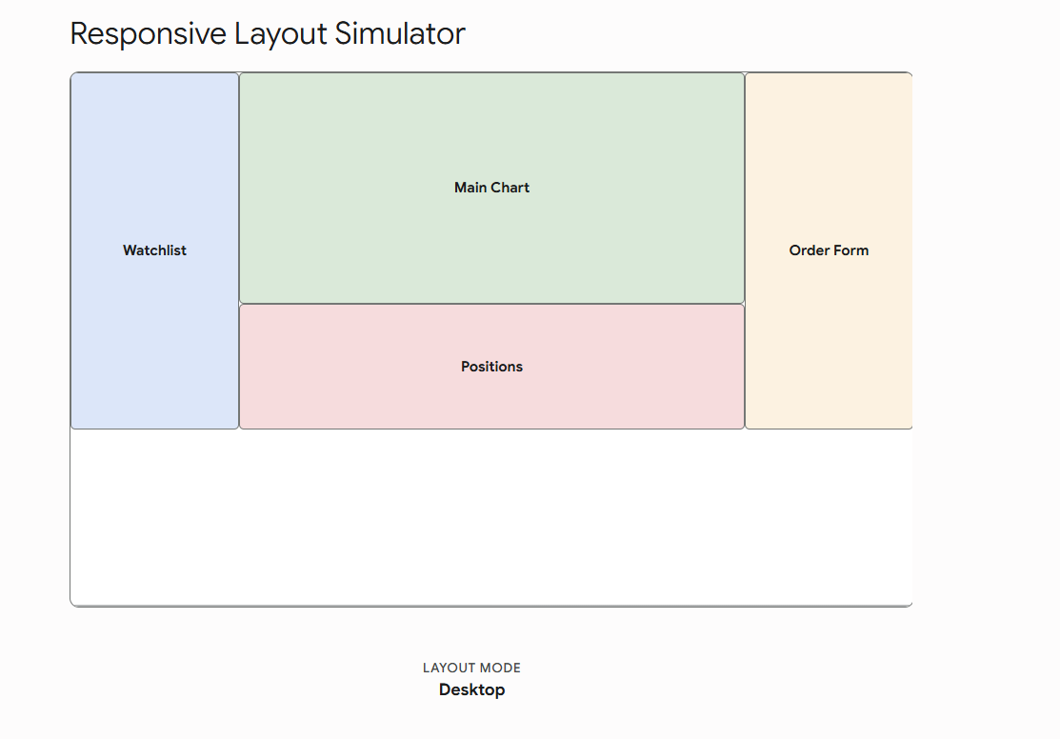
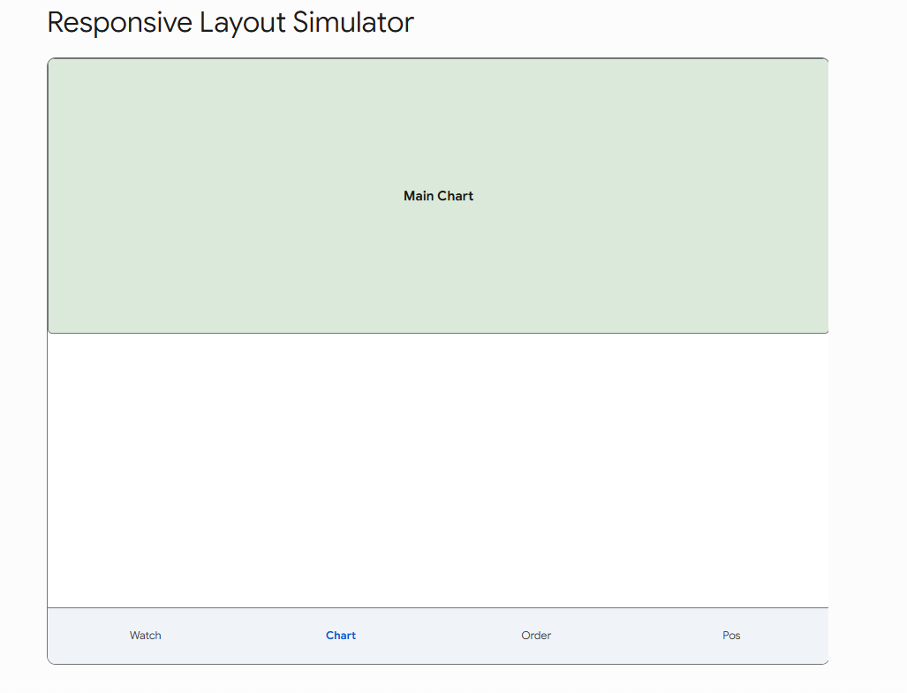

Key Insight: Even for manual trades placed through your custom terminal, route the execution through your backend Risk Management Module. This prevents human emotion from overriding the hard-coded loss limits you set for the bot.

Your decision to trade In-The-Money (ITM) options 2 to 3 weeks out from expiry is a highly professional, institutional-grade approach.
Most retail traders fail because they buy current-week Out-of-the-Money (OTM) options, which are destroyed by "Theta" (time decay). By rolling your expiry 2 to 3 weeks forward and staying ITM, your options will have a high "Delta" (typically 0.60 to 0.75). This means your option will behave very similarly to Nifty futures, allowing you to capture pure momentum without fighting the clock.
Here is an analysis of your Risk Engine logic and the most reliable, easily programmable algorithmic strategies for this exact setup.

The Core Strategies for ITM Momentum Buying
Since your strategy relies on high-Delta options, your algorithmic triggers must focus purely on directional momentum. Here are three common, highly effective strategies that are easy to code into a bot:
1. The Opening Range Breakout (ORB) with VWAP
- The Logic: The market often establishes its daily trend in the first 30 to 60 minutes.
- The Execution: The bot monitors the High and Low of Nifty's first 15-minute candle. If the price breaks the High and is trading above the VWAP (Volume Weighted Average Price), the bot automatically fires a Market Order for your 2-week ITM Call Option.
- Why it works here: ORB strategies capture explosive morning moves. With a tight "Per trade stop loss point," you get stopped out quickly if it's a fake breakout, but capture massive gains if the trend sustains.
2. The EMA Pullback (Trend Following)
- The Logic: Buying breakouts can sometimes result in "whipsaws" (fake breakouts). Buying the pullback in an established trend is safer.
- The Execution: The bot tracks the 9-EMA (Exponential Moving Average) and 21-EMA on a 5-minute chart. When the 9-EMA is above the 21-EMA (uptrend), the bot waits for the price to dip and touch the 21-EMA. As soon as a green confirmation candle forms on the 21-EMA, it executes the ITM Call buy.
- Why it works here: Pullbacks offer the best risk-to-reward ratio, allowing your hard-coded "Per trade gain point" to easily exceed your stop loss.
3. Volatility Squeeze (Bollinger Band Breakout)
- The Logic: Markets alternate between periods of low volatility (consolidation) and high volatility (expansion).
- The Execution: The bot monitors Bollinger Bands. When the upper and lower bands squeeze tightly together, it indicates a big move is coming. The moment the price closes outside the bands with high volume, the bot executes the trade in that direction.

4. The Supertrend Rider (Automated Trend Following)
The Supertrend indicator is the "holy grail" for retail algo traders because it inherently includes a trailing stop-loss mechanism.
- The Logic: Supertrend uses the Average True Range (ATR) to draw a dynamic support/resistance line. It calculates the current volatility and stays a safe distance away from the price.
- The Execution (.NET Logic): * Calculate ATR(14) and Supertrend(10, 3).
  - Entry: When the 5-minute or 15-minute candle closes above the Supertrend line, the trend flips to green. Your engine fires a Market Buy for the ITM Call.
  - Exit: You hold the trade until either your hard-coded "Per trade gain point" is hit, OR the price closes below the Supertrend line (which acts as a dynamic stop-loss).
- Why it works for you: It removes all human guesswork from trailing a stop loss. It keeps you in massive trends all day and stops you out quickly when the trend breaks.

5. NR7 Breakout (Volatility Contraction)
"NR7" stands for Narrowest Range of the last 7 candles. Markets move from periods of low volatility to high volatility.
- The Logic: If the current candle has the smallest High-Low range compared to the previous 6 candles, the market is compressing like a spring. A breakout is imminent.
- The Execution (.NET Logic):
  - Array check: CurrentCandle.Range < Min(Previous 6 Candles Ranges).
  - If true, the system sets a pending Buy Stop order just above the High of that NR7 candle.
  - If the next candle breaks that high, the order executes.
- Why it works for you: Because you are checking the VIX before trading (as per your Kill Switch rules), an NR7 setup during a moderate VIX day usually results in a violent, highly profitable price expansion.

6. MACD Zero-Line Crossover (Momentum Confirmation)
Buying random dips can be dangerous. The Moving Average Convergence Divergence (MACD) ensures you only buy a dip when momentum is mathematically turning back in your favor.
- The Logic: Instead of just buying when a fast moving average crosses a slow one, MACD measures the distance between them.
- The Execution (.NET Logic):
  - Calculate MACD(12, 26, 9).
  - Entry: The bot monitors the MACD Histogram. When the MACD line crosses above the Signal line (a bullish cross) specifically while both lines are below the zero line (meaning the market was oversold but is now reversing), the bot fires the ITM Call buy.
- Why it works for you: It is a fantastic programmatic filter. It prevents your bot from buying into a falling knife.

Integrating Your Kill Switch Rules
Your rule set is phenomenal because it perfectly brackets market risk. Here is how your algorithm will process these rules sequentially on every single tick:
- Pre-Trade Check (Rule 5): Before any strategy signal is accepted, the bot checks India VIX. If VIX < 11 (premium decay, slow markets) or VIX > 22 (erratic, dangerous swings), the bot ignores the signal.
- Execution (Rules 6 & 7): The trade is fired. The bot instantly places a bracket order (or manages it internally) using your strict Per Trade SL and Gain targets.
- The Master Loop (Rules 1, 2, 3, & 4): Every second, the Risk Management System (RMS) checks the daily state against the Redis database.
  - Did the MTM loss cross the Max Loss Per Trade?
  - Has the day's total loss breached the Max Daily Loss?
  - Have we hit the max trade limit (e.g., 5 trades) or max failed trades (e.g., 3 SL hits)?
- The Kill Sequence: If any of those limits are breached, the bot instantly fires market square-off orders, sets the Redis kill_switch:locked state to TRUE, and starts the time-delay on your TOTP generation page.
Below is an interactive simulator of your Risk Engine. You can adjust the parameters and simulate market trades to see exactly how your backend will evaluate the rules, trigger the Kill Switch, and lock down your TOTP interface.

do not need to manually copy your API Key or API Secret every morning. Those values are permanent for your Fyers developer app and should be stored securely once in your backend (e.g., in your .env file alongside your encrypted TOTP seed).
Here is exactly how the daily process works based on your planned architecture:
- What Actually Expires: While your API Key is permanent, Fyers mandates a daily login to generate a new access_token (your active session token for the day).
- The Automated Backend Flow: Your core backend engine includes an Authentication Manager designed specifically to handle this daily OAuth redirect flow. Because you are keeping the Fyers TOTP seed in your application's secure secret manager , the Authentication Manager can decrypt the seed and generate the required 6-digit PIN dynamically.
- Your Daily Action: Instead of copying keys, your frontend API Configuration & Login page will simply feature a button to initiate the daily login flow. When you click it (usually before the market opens), your system uses the stored API keys and the dynamically generated TOTP code to log in, capture the request token, and automatically save the new access_token to maintain the active session for the day.
Time and Asset Constraints.
By restricting your trading window to 9:30 AM – 3:10 PM, you effectively bypass the unpredictable volatility of the market open and the forced square-off chaos at the close. Furthermore, restricting your TOTP access during pre-market and market-close hours mathematically eliminates the possibility of revenge trading when the market is most erratic.
Here is the fully updated master prompt for your agentic IDE, incorporating these exact time, instrument, and TOTP restrictions.

